**CHAPTER 1**

**INTRODUCTION**

**1.1 PROBLEM DEFINITION**

Creation of websites and web apps are the prime eye candy’s for every user and consumer and business provider in 2022 and the rising number of startups require websites and web apps built every day or every hour in some cases require faster solutions. Sometimes big projects and web based companies with large databases cannot afford to implement their apps with the first design idea they get. Hence they’ll need services to test their design cases and also learn little out of it as well.

As a user/learner, there are a plethora of websites which promise the learners in helping them learn HTML, CSS and JavaScript. This website will put that into action. It helps in making the websites more accessible in design helps in real-time website design testing. It can create and spark design ideas and can be put to best use of testing colors in a website/web-app.

**1.2 OBJECTIVES**

Once developed, the application will provide services like:

* Comfortable and Legible layout.
* Easy to use and Colour-Friendly Output.
* Colour Theory and Preview Design will be incremental to our technology.
* Data collected from the user will be secure and only be used inside the application.

**1.3 METHODOLOGY TO BE FOLLOWED**

* First the user

**1.4 EXPECTED OUTCOMES**

* As a CSI Student, our first priority is safeguarding your data.
* The sketchy engine creates beautiful sketches from any picture.
* We can send photos and any abstract art and convert it into hand drawn sketches.
* The passwords and user information safely stored in device cannot be shared.
* One of the main outputs are live video sketching
* We can use the live sketching feature to explain and direct ideas in online meetings.

**CHAPTER 2**

**FUNDAMENTALS OF PYTHON**

**2.1 INTRODUCTION TO PYTHON**

[Python](https://www.geeksforgeeks.org/python-programming-language/) is a commonly and extensively used general-purpose, high-level programming language. Guido van Rossum in 1991 was the founder of Python and was later developed by Python Software Foundation. It was primarily designed to emphasize on code readability, and its syntax allows programmers to express ideas in few lines of code. Python can be used for things like:

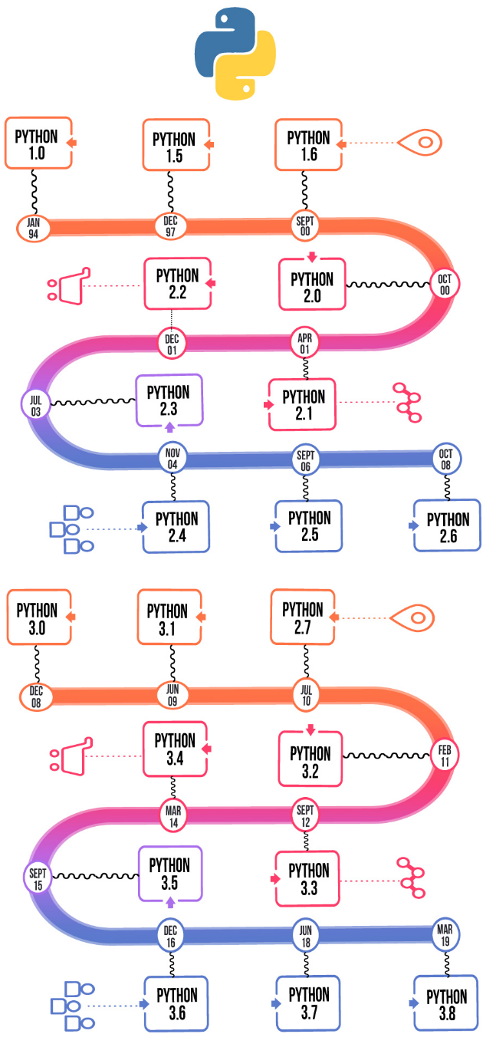

Figure 2.1: Different versions of Python over the years

**2.1.1 ENTITY-RELATIONSHIP (ER) MODEL**

The Entity-Relationship (ER) Model is an attractive high level conceptual data model. It has an entity which may be an object with a physical existence like a particular car, house, person or employee or it may be an object with a conceptual existence like an organization, a profession, or a university course. Each entity has attributes—the definite properties that characterize it. For example, a student entity may be described by the student’s name, age, address, USN etc.

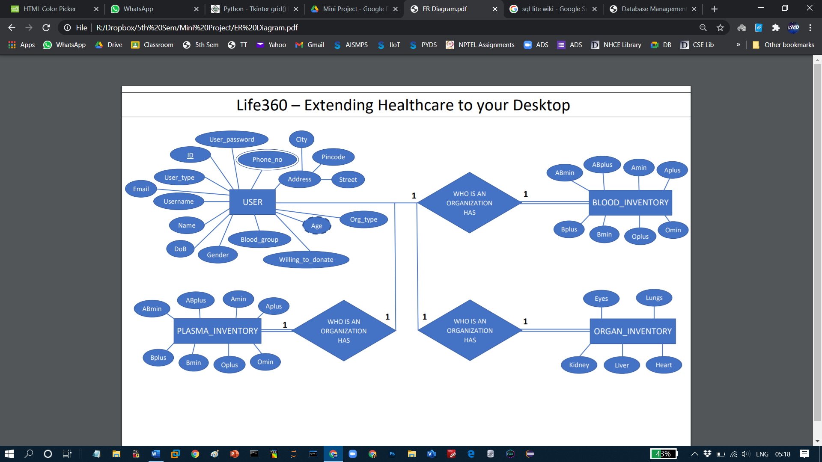

Figure 2.2: DBMS Component Modules

**2.1.1.1 ENTITY-RELATIONSHIP (ER) MODEL**

The Entity-Relationship (ER) Model is an attractive high level conceptual data model. It has an entity which may be an object with a physical existence like a particular car, house, person or employee or it may be an object with a conceptual existence like an organization, a profession, or a university course. Each entity has attributes—the definite properties that characterize it. For example, a student entity may be described by the student’s name, age, address, USN etc.

**CHAPTER 3**

**REQUIREMENT SPECIFICATION**

**3.1 HARDWARE REQUIREMENTS**

* Processor- Intel® Core™ i5-9300HF CPU @ 1.80GHz 1.99 GHz
* RAM- 256 MB or Above
* Graphic Processor: Inbuilt or additional GPU
* System Type- 64-bit operating system, x64-based processor

**3.2 SOFTWARE REQUIREMENTS**

* Windows 10 Operating System
* Programming Language Used: Python Programming Language
* Query Language: MySQL
* IDE and Workbench – Visual Studio Code

**CHAPTER 4**

**FUNDAMENTALS OF DBMS**

**4.1 DESIGN GOALS**

This mini project has ensured that the user has an interactive and explorable environment. The interface is user friendly, simple to understand and has tried to ensure that there are no bugs.

Table 4.1: Various widgets available in Tkinter

|  |  |
| --- | --- |
| WIDGETS | DESCRIPTION |
| Label | This widget is used to display text or image on the window/frame |
| Button | This widget is used to add buttons to the user interface |
| Canvas | This widget allows one to draw pictures and different types of layouts like texts, graphics etc. |
| Entry | This widget is used to take as input, a single line text entry from user |
| Frame | This widget is used as box or container. It holds and organizes the widgets in an orderly fashion |
| SpinBox | This widget allows users to select from a given number of values |
| ComboBox | This widget contains a down arrow to select from a list of options |
| CheckButton | This widget displays a number toggle buttons which represent various options from which user can select any number of options. |
| RadioButton | This widget is similar to the CheckButton but allows only one option to be selected |
| Scale | This widget is used to provide a slider which allows the user to select any value from the scale |

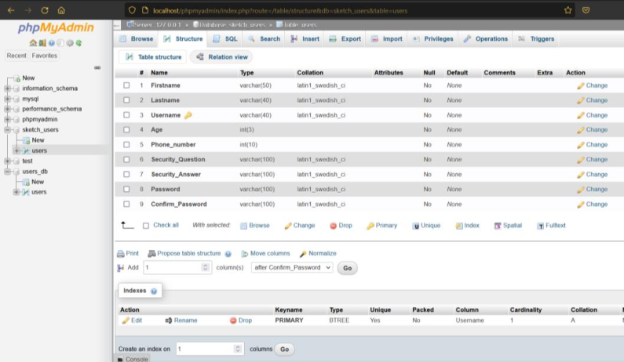

We are creating a profile using the above function. We are using an SQL Database to store the values of the login details and register details.

**CHAPTER 8**

**RESULTS**

**8.1 Landing Page Website**

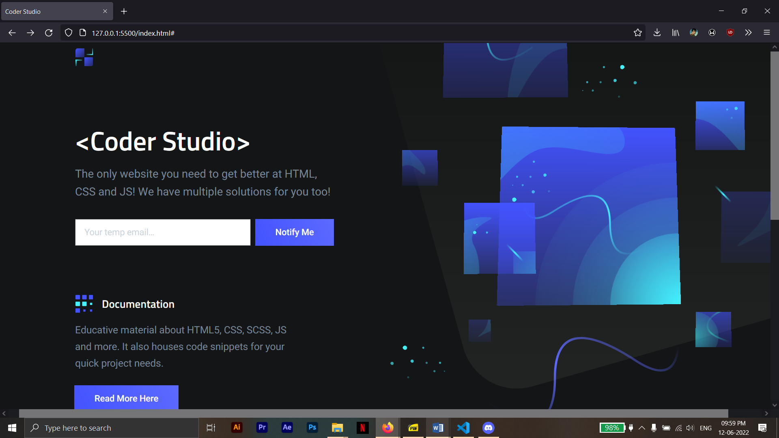

**Figure 8.1.1: Screen Shot of the Landing Page**

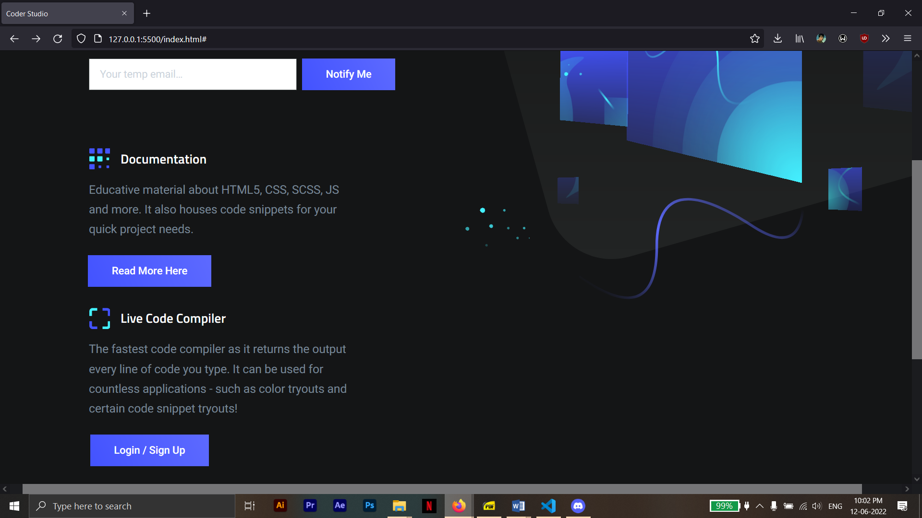

**Figure 8.1.2: Screen Shot of the Landing Page**

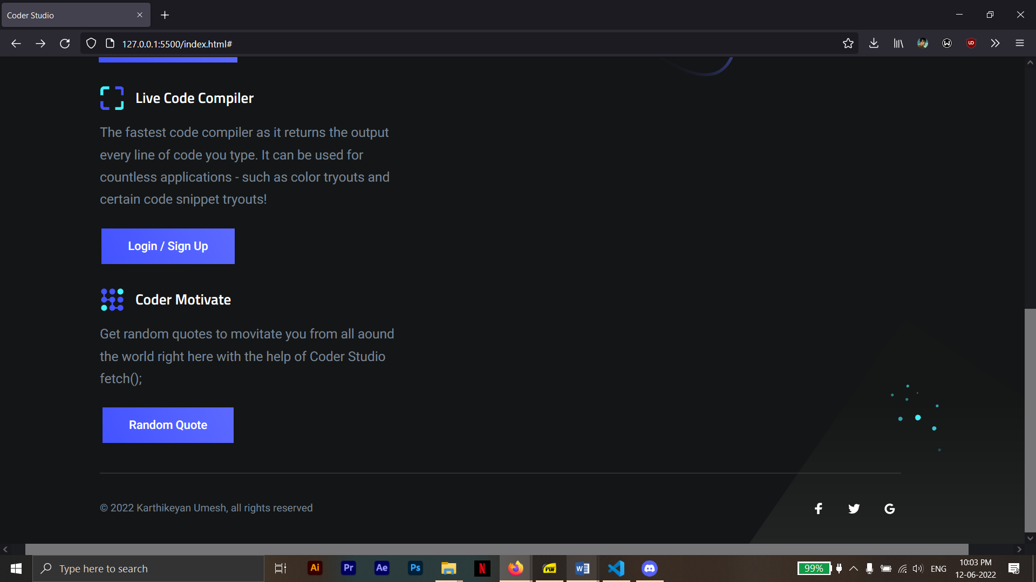

**Figure 8.1.3: Screen Shot of the Landing Page**

**8.2 REGISTERING A NEW USER (VALIDATION)**

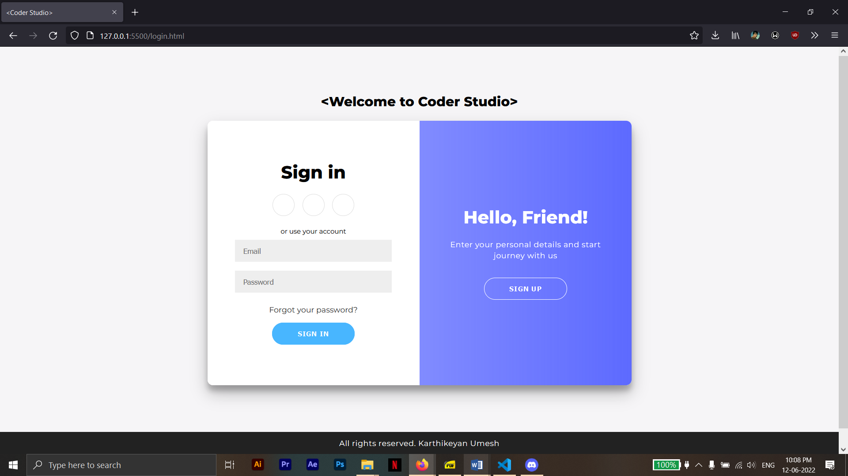

**Figure 8.2.1: Sign-In Screen Shot**

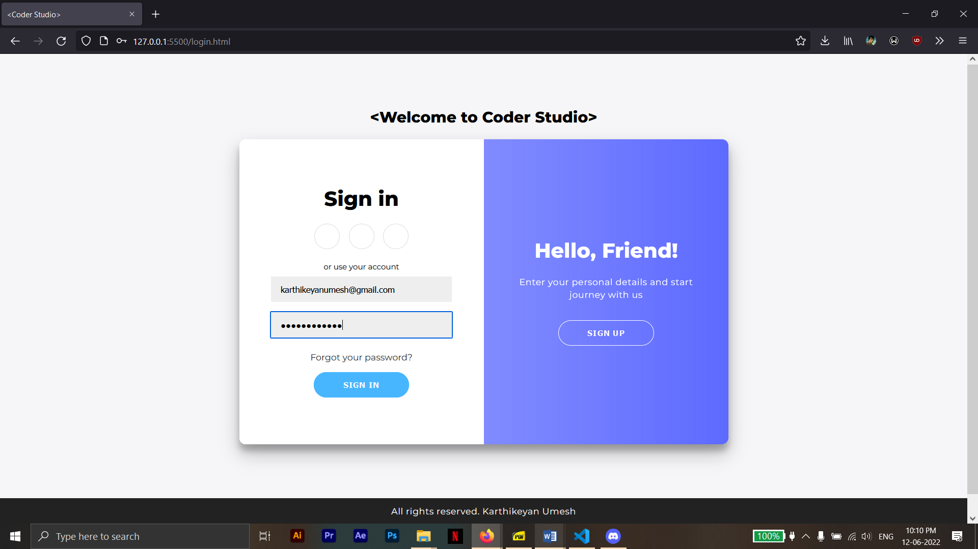 **Figure 8.2.2: Sign-In Screen Shot**

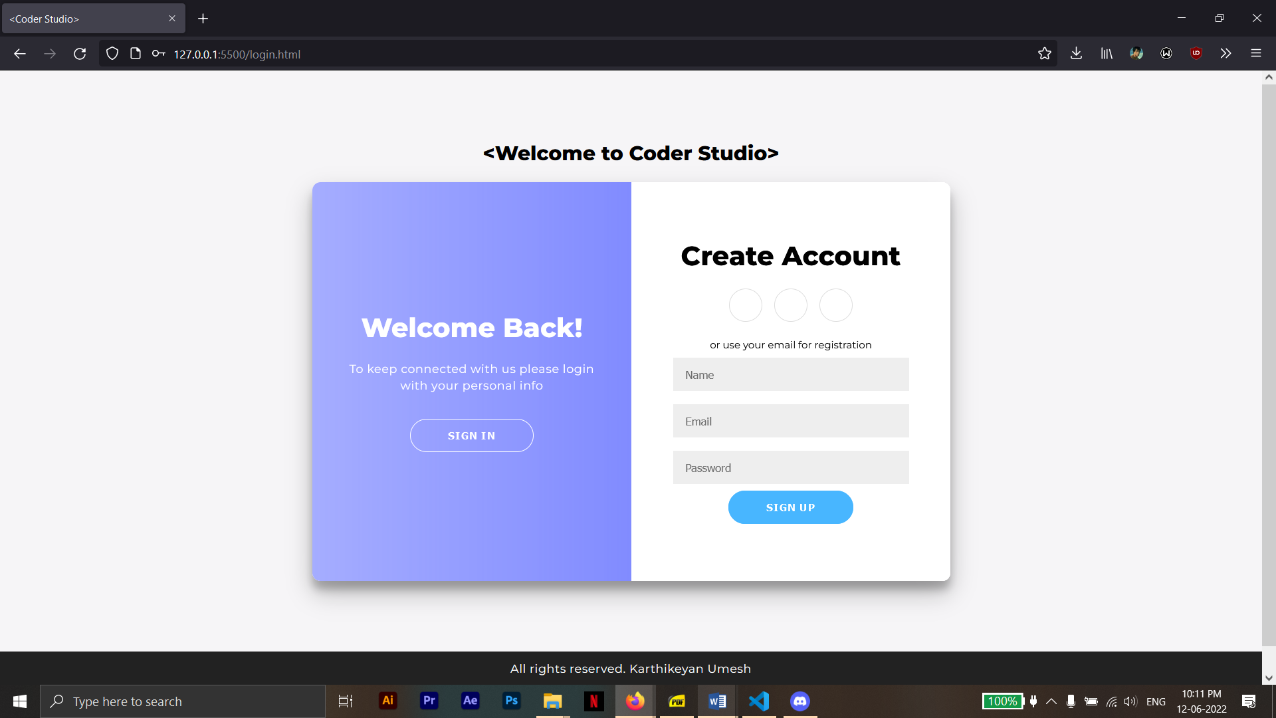

**Figure 8.2.3: Sign-Up Screen Shot**

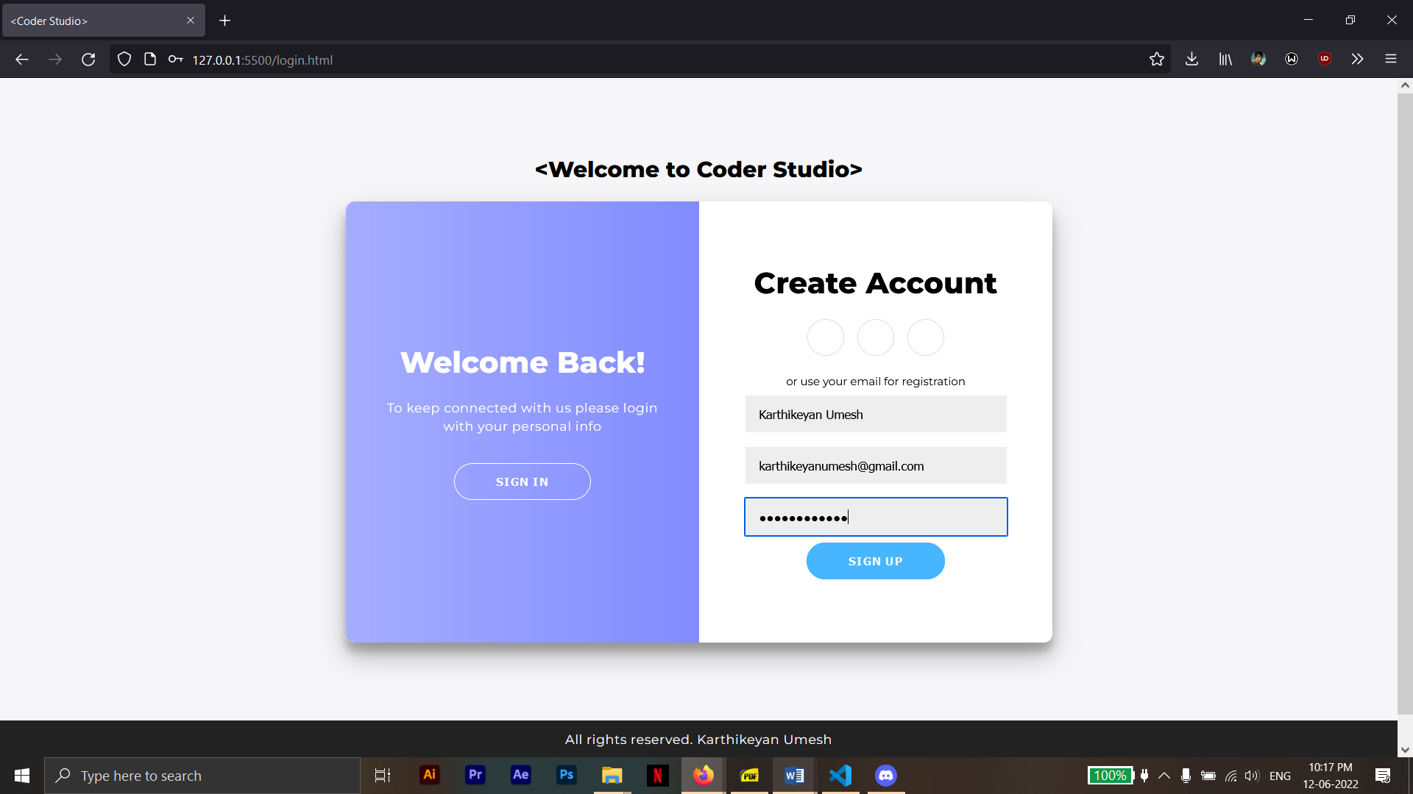

**Figure 8.2.4: Sign-Up Screen Shot**

**8.3 Code Editor Page**

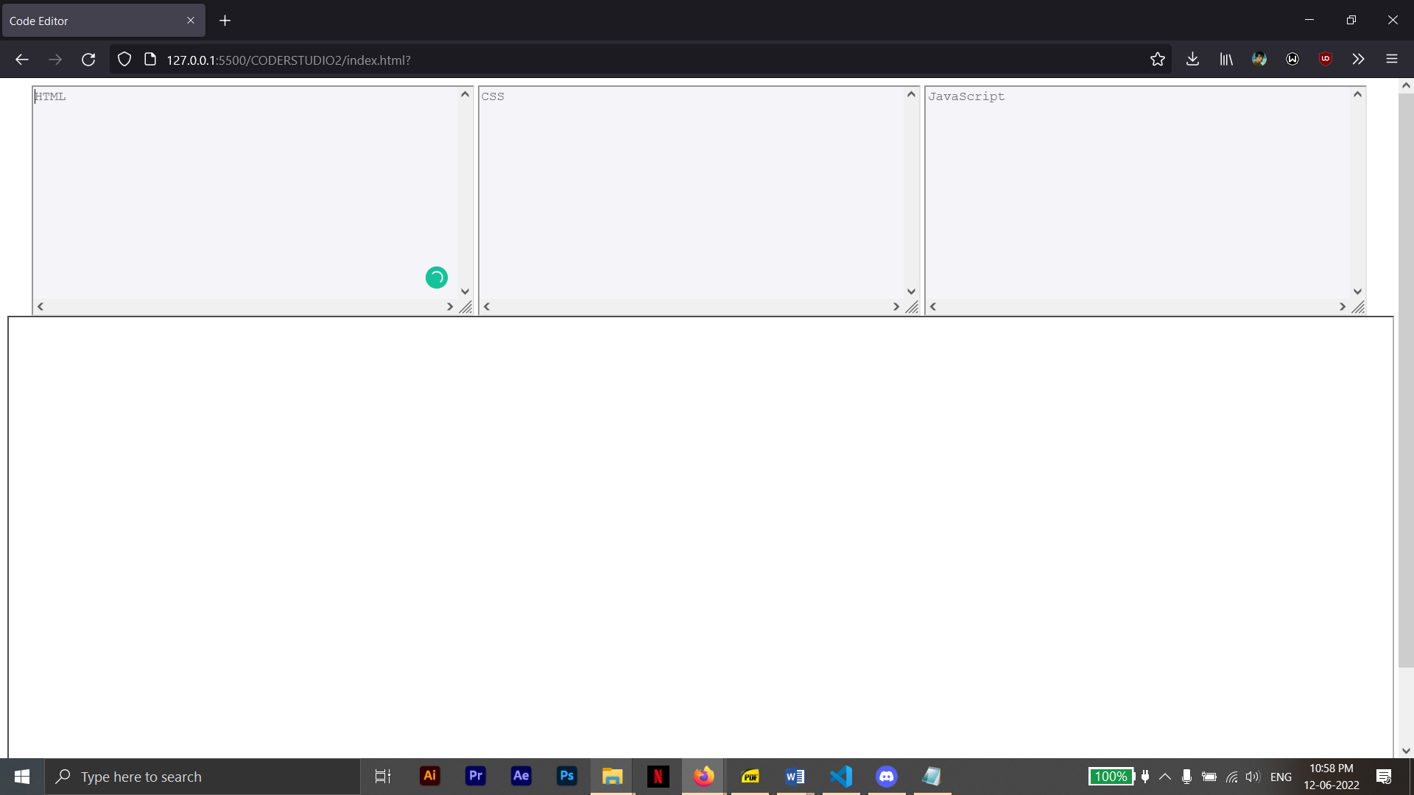

**Figure 8.3.1: Code Editor Screen Shot**

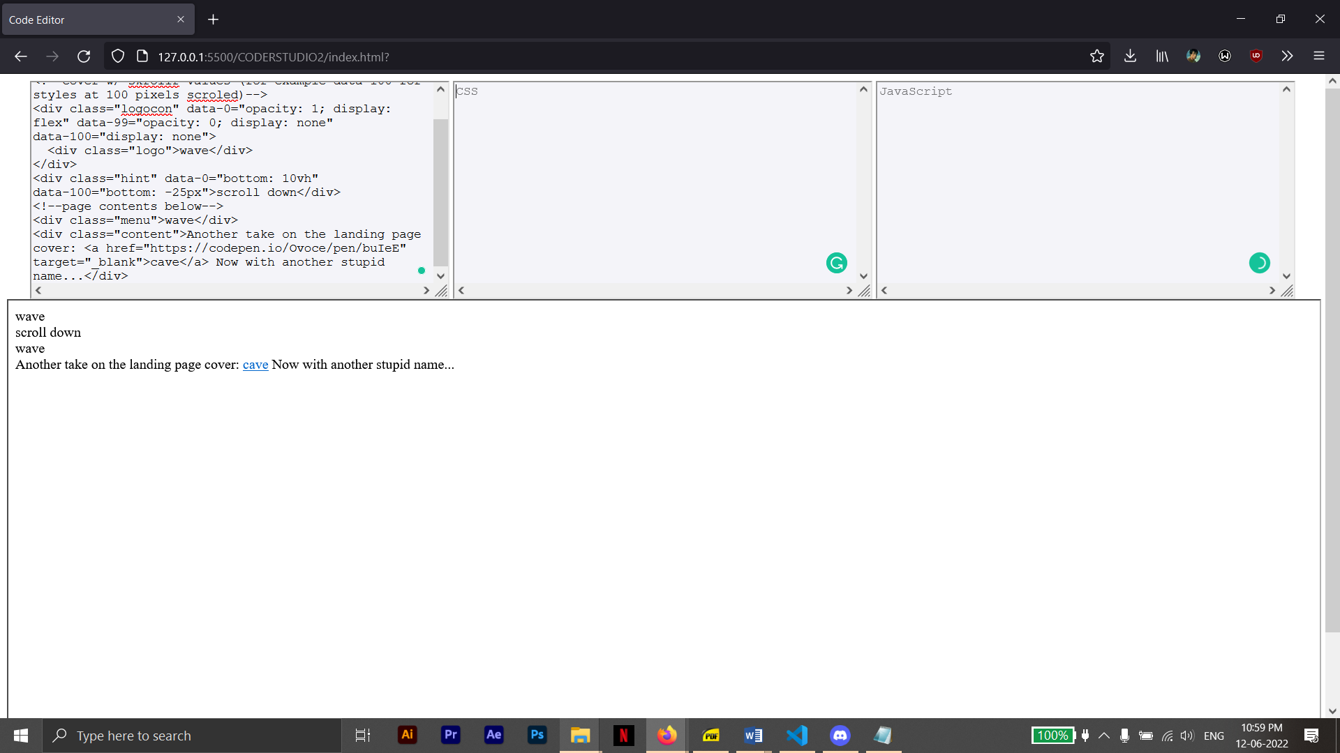

**Figure 8.3.2: Code Editor Screen Shot**

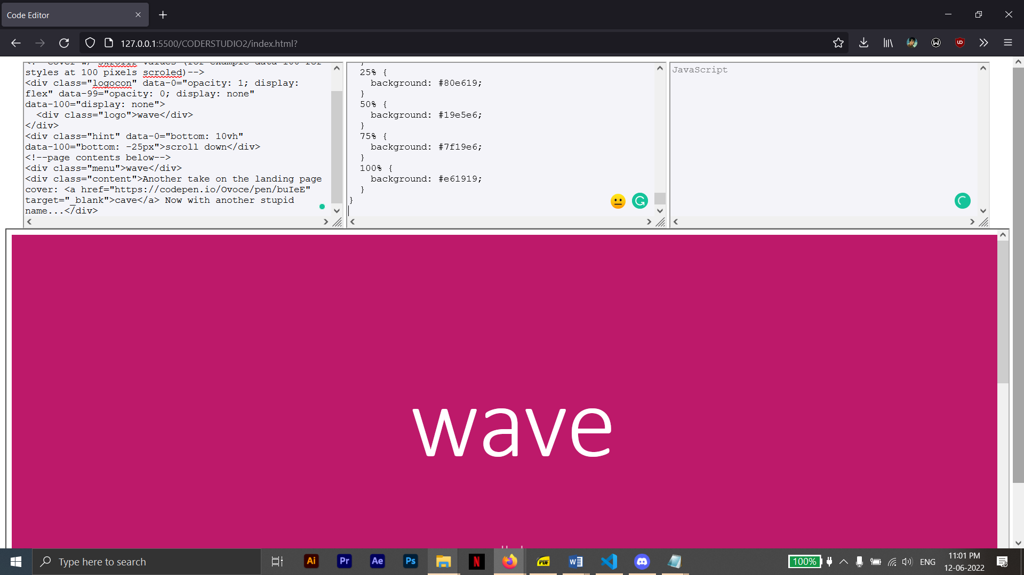

**Figure 8.3.3: Code Editor Screen Shot**

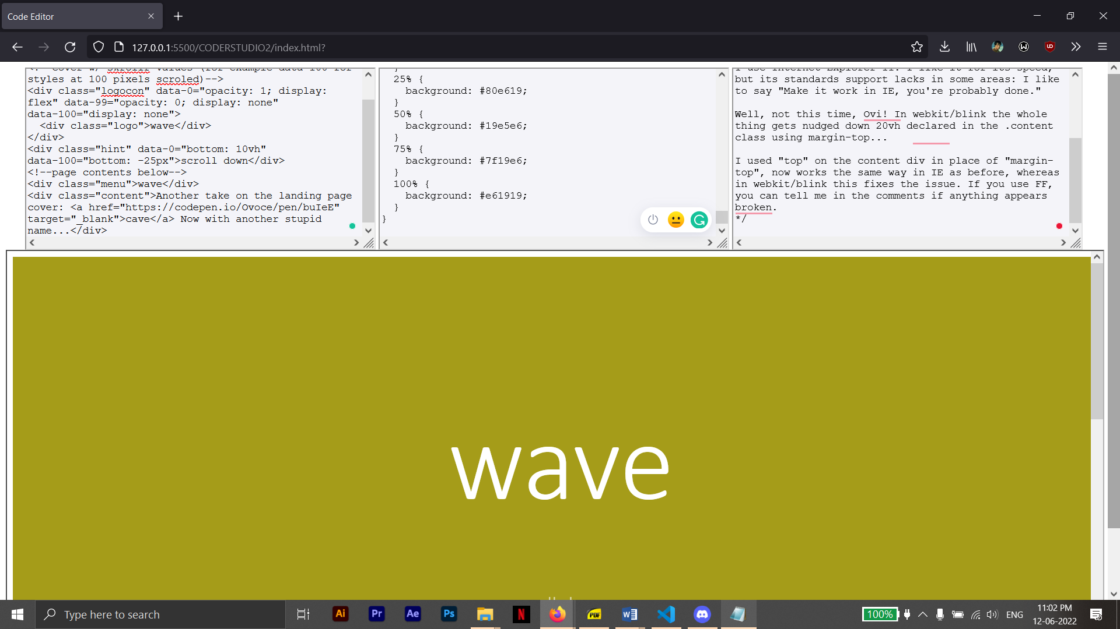

**Figure 8.3.4: Code Editor Screen Shot**

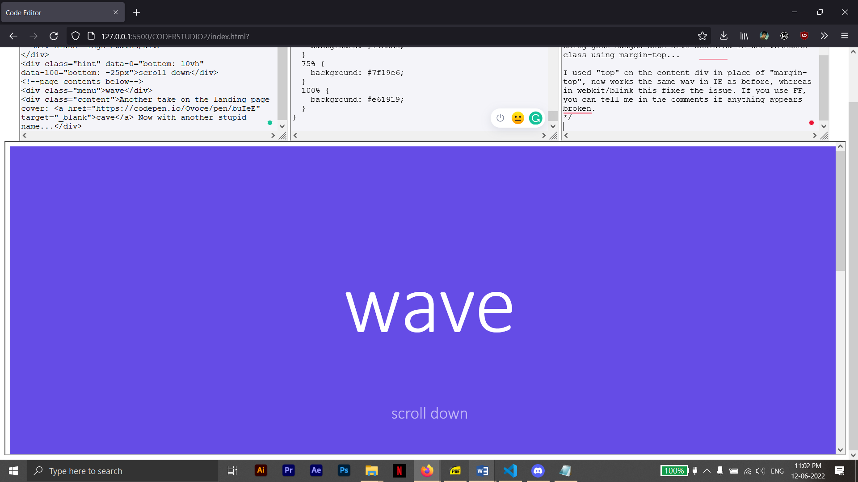

**Figure 8.3.5: Code Editor Screen Shot**

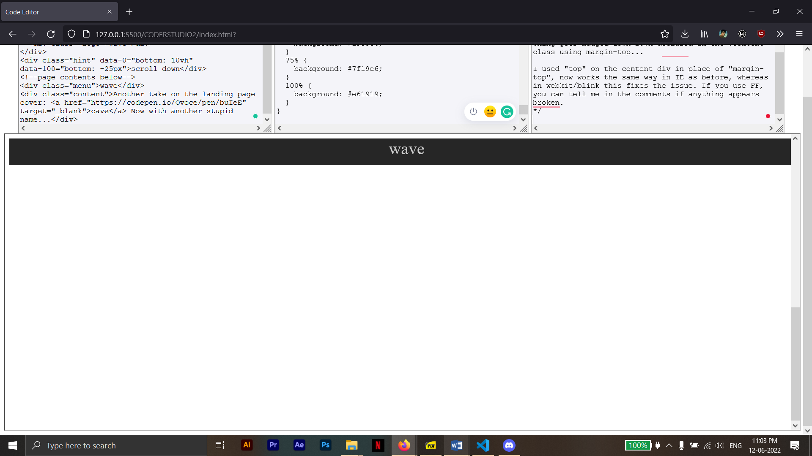

**Figure 8.3.6: Code Editor Screen Shot**

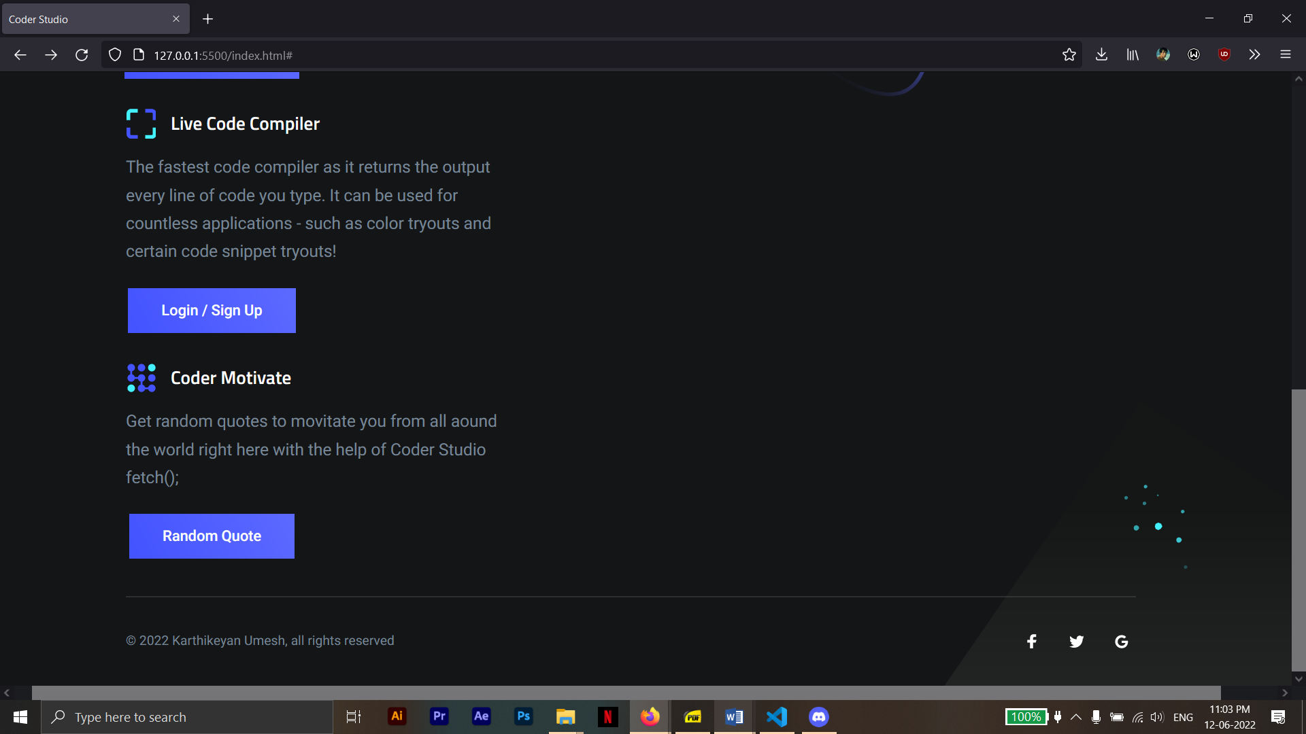

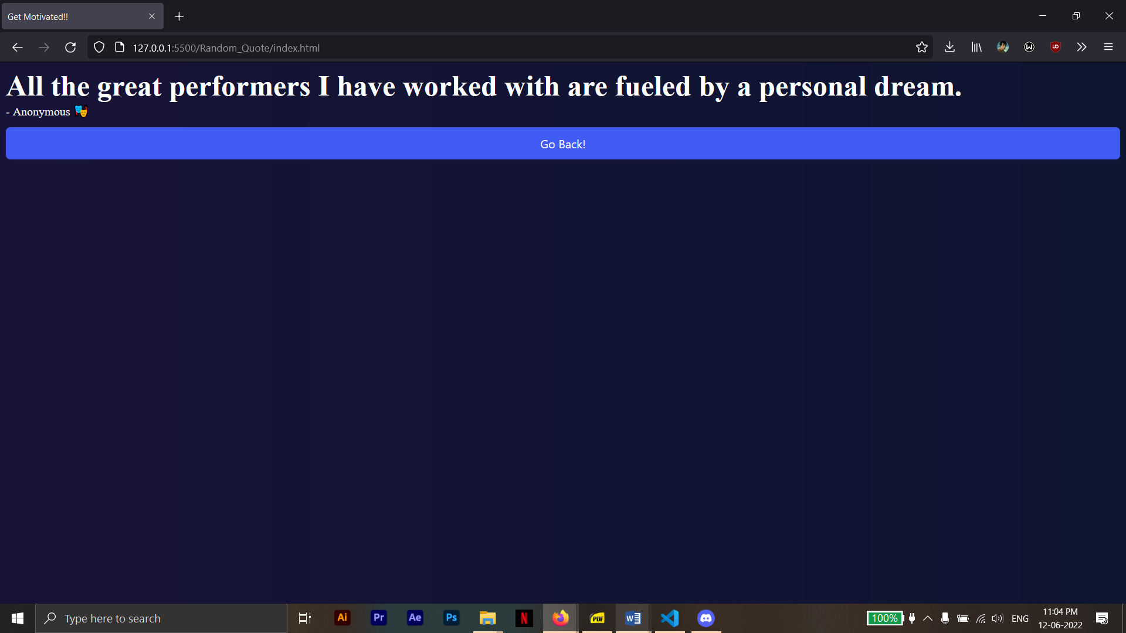

**Figure 8.3.7: Coder Motivate Screen Shot**

**CHAPTER 9**

**CONCLUSION**

The mini project titled CODER STUDIO is being successfully implemented using HTML, CSS and JavaScript concepts accomplishing the goals it had set out in the objectives and design sections of this report.

The project CODER STUDIO was able to give the users exactly what they needed. The main purpose of CODER STUDIO was to provide a platform for users to test their websites and have dry run with basic design ideologies in real time. And the code editor runs the commands in real time hence it saves time for large teams willing to collaborate and it gives insight into color theory where testing the colors and color pallet’s inside a brand’s website and web app. It houses HTML, CSS, and JavaScript where all 3 sections can produce an output using iframe.

The Coder Studio Project also houses another feature which is to get a random quote which motivates them every time they click on it! It works with the fetch() command and helps in users to have a fun motivation always at the back of their heads to keep them motivated as they continue studying or working.

The Coder Studio also houses a state of the art Login and Registration Page which helps the users to be familiar with the website and web app and also it helps them stay connected to the website more with information collected by it. The security provided is also of good value.

**REFERENCES**

[1] <https://www.javatpoint.com/>

[2] <https://www.w3schools.com/>

[3] <https://www.w3.org/Style/CSS/Overview.en.html/>

[4] <https://code.visualstudio.com/>

[5] <https://www.phpmyadmin.net/>

[6] <https://en.wikipedia.org/wiki/PhpMyAdmin>

[7] <https://dev.mysql.com/doc/>